Assignment 1
- Install Docker and Docker Compose on your machine.
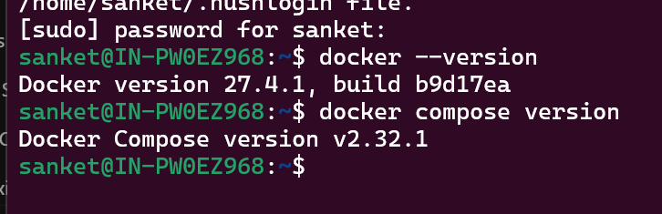
- Verify the installation by running a test container.
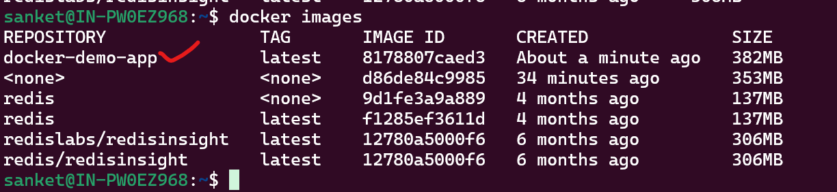
- Create a simple web application (e.g., a Python Flask, DotNet, Java or Node application).
Sample web application which running on port 8080
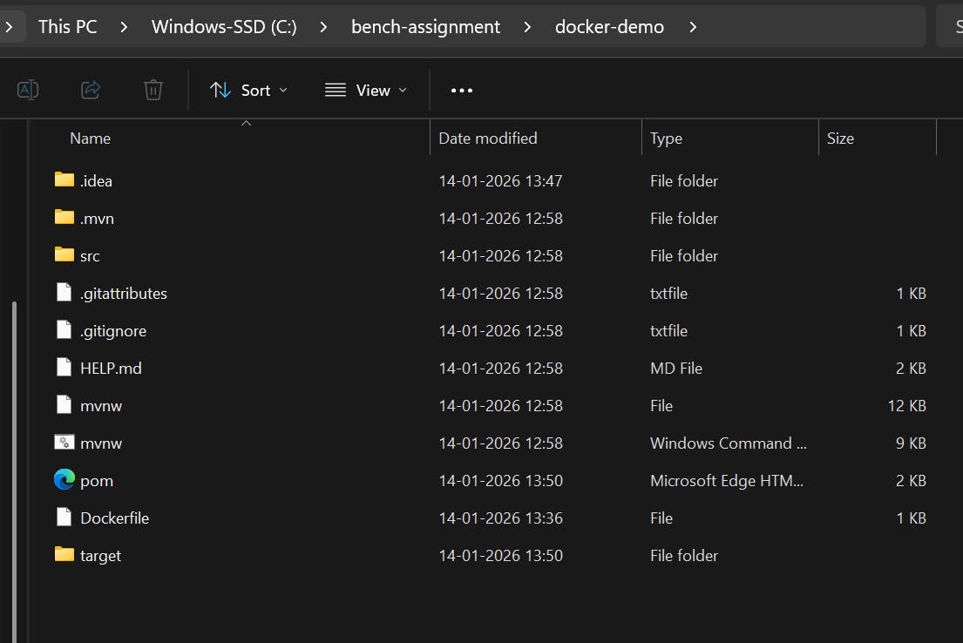
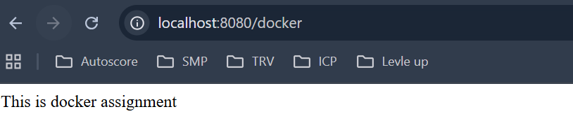
- Write a Dockerfile to containerize the application.
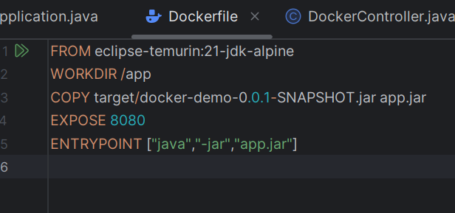
- Build the Docker image and run a container from it.
Used below command to build image
docker build -t docker-demo-app .
- Use Docker commands to list, start, stop, and remove containers.
- Inspect running containers and view logs.
Used below command to run application
docker run -p 8080:8080 docker-demo-app
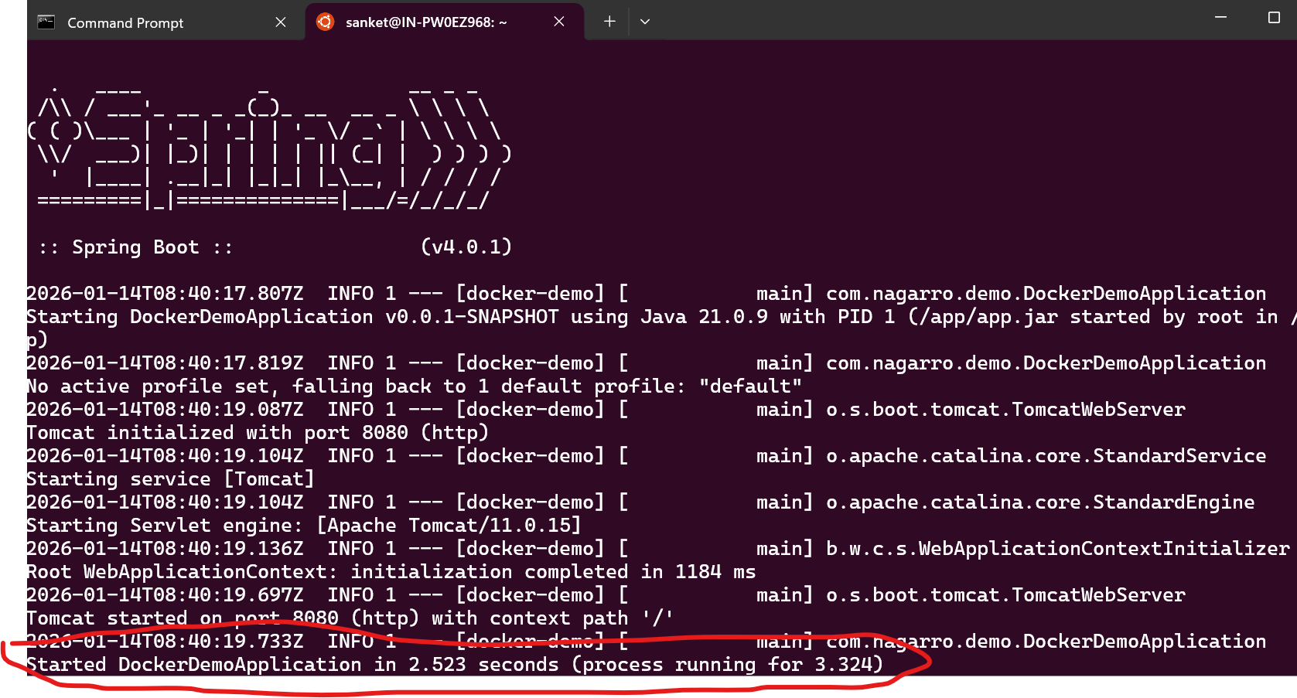
Logs
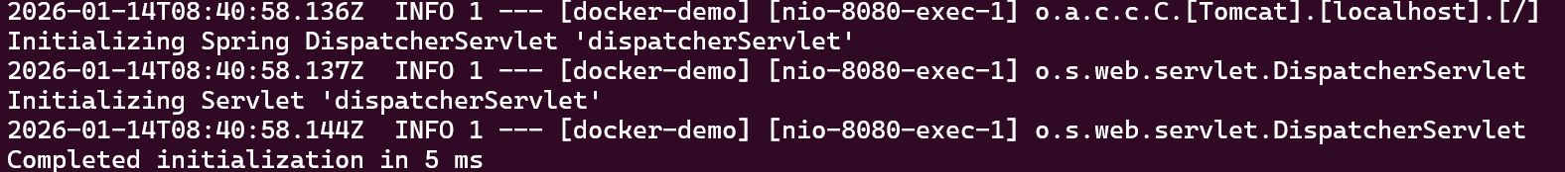
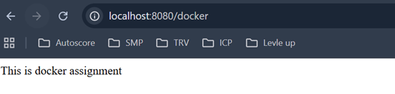
- Write a docker-compose.yml file to define a multi-container application.
docker-compose build command = docker-compose up --build
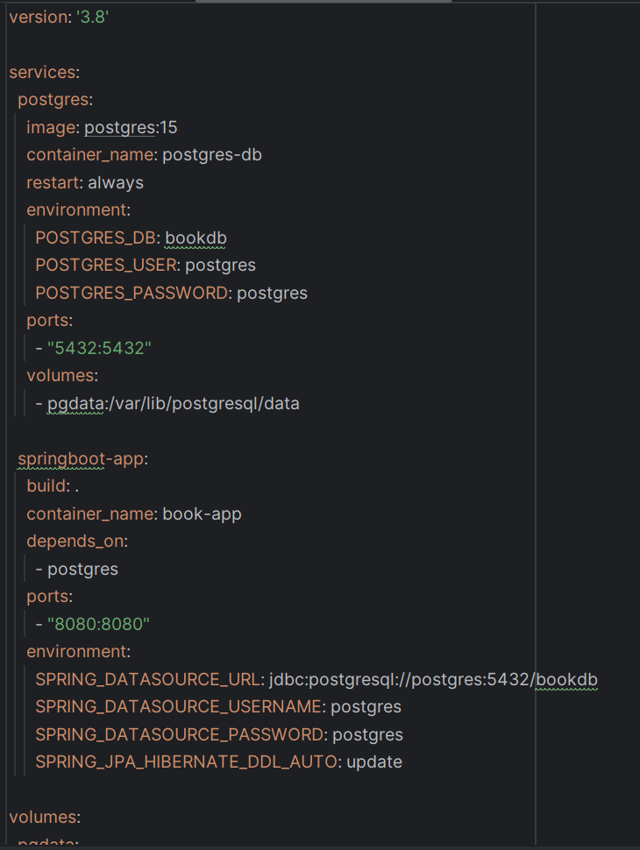
- Use Docker Compose to bring up the application and ensure all services are running correctly.
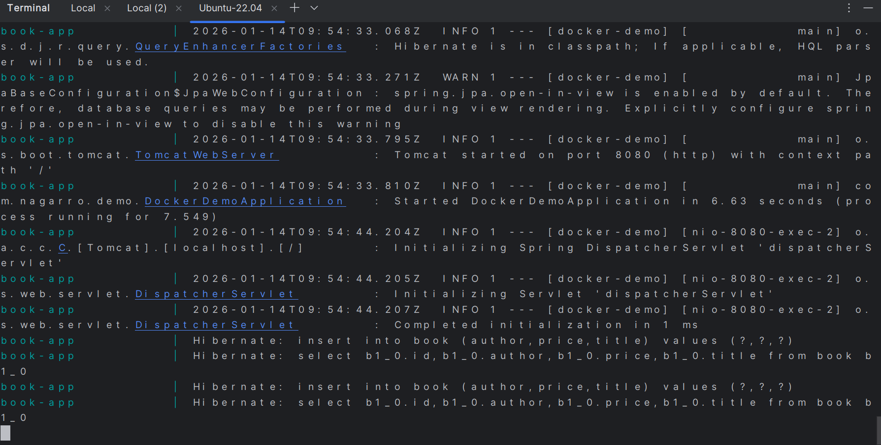
application running logs
- Create a private Docker registry or use Docker Hub.
docker login -u sanketdes
by giving password logged in Successfully
- Push your Docker images to the registry.
Tagged image
docker tag docker-demo-app:latest sanketdes/docker-demo-app:latest
docker push sankedes/docker-demo-app:latest
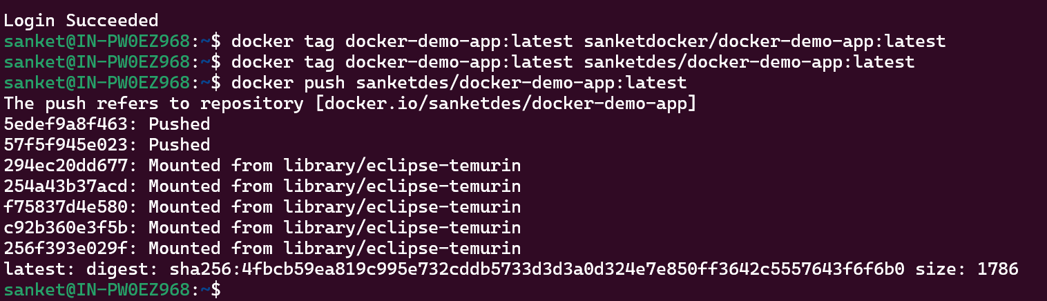
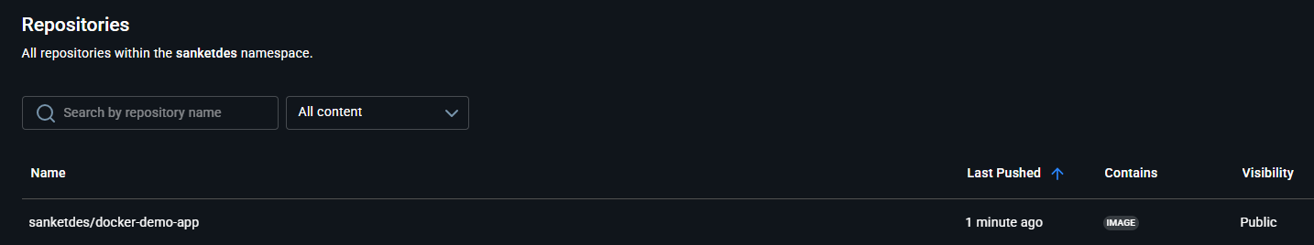
- Pull the images from the registry and run them locally.
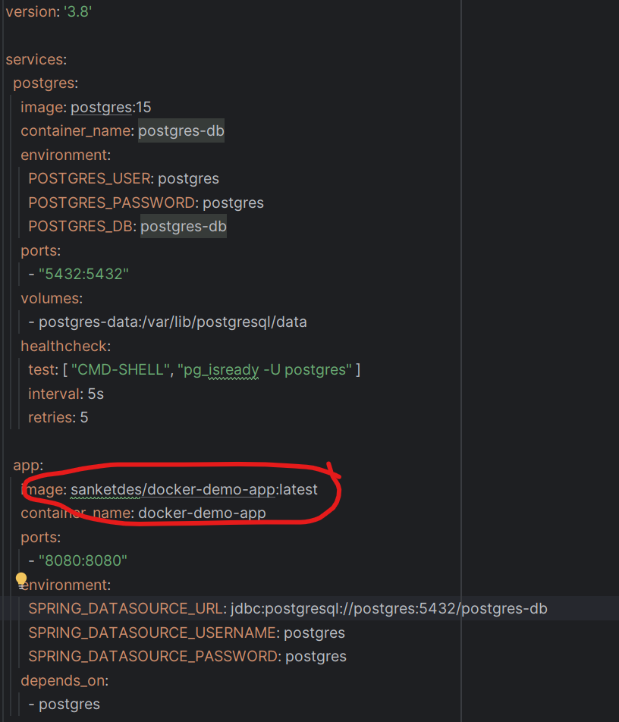
Pulled image running using docker compose file

